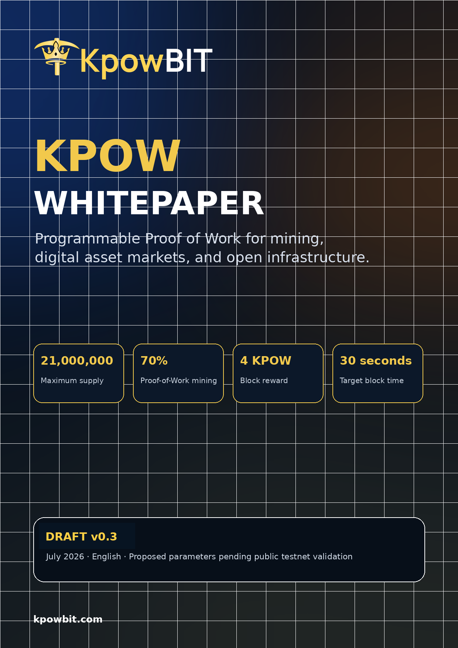

Important Notice
Draft status, scope, and legal limitations
Draft document
This whitepaper is a technical and product design document. It is not an offer of securities, a promise of financial return, or investment advice.

KPOW Chain, the KPOW coin, KpowBIT Exchange, and the planned Mining Rental Platform are under active design and development. Chain parameters, token distribution controls, presale terms, activation dates, marketplace rules, and regulatory availability may change following engineering review, public testnet results, security assessments, partner readiness, market conditions, and applicable laws.
Mining, digital assets, token sales, and trading involve substantial risks. Mining output depends on hardware, difficulty, network conditions, pool performance, electricity, token prices, and other variables. KpowBIT does not guarantee profitability, token value, exchange liquidity, uninterrupted service, or completion of roadmap items on a fixed date.
Prospective users, miners, providers, purchasers, and contributors should conduct independent technical, financial, tax, and legal review. Participation may be restricted in some jurisdictions. KYC, sanctions screening, eligibility rules, and additional disclosures may apply.
Document field | Value
Version | Draft v0.3
Publication date | July 2026
Language | English
Project website | kpowbit.com
Exchange access | trade.kpowbit.com
Chain parameter status | Proposed; pending public testnet validation
Maximum supply | 21,000,000 KPOW

This draft includes proposed public RPC and wallet settings for documentation purposes. Endpoint hostnames, project wallets, source releases, genesis files, and binaries must be verified through official signed announcements before use.

Contents
Whitepaper structure
- Executive Summary
- Vision and Design Principles
- Market Context and Problem
- KPOW / KpowBIT Ecosystem
- KPOW Chain Architecture
- Network Parameters
- Monetary Policy and Mining Schedule
- Tokenomics and Distribution
- Presale Framework
- KpowBIT Exchange
- Mining Rental Platform
- KPOW Utility
- Security and Risk Controls
- Governance and Treasury Transparency
- Era Plan
- Risk Factors
- Legal and Regulatory Considerations
- Monetary Calculations
- Terminology
- Pre-Mainnet Checklist
Reading guide
Sections 5-8 describe the proposed chain and monetary design. Sections 9-11 describe product delivery. Sections 13-17 describe controls, governance, roadmap, and risk.

1. Executive Summary
Programmable Proof of Work for mining and digital asset markets
KPOW is proposed as a fixed-supply, EVM-compatible Proof-of-Work coin and settlement network. KpowBIT is the product ecosystem built around that network, beginning with a presale, followed by a digital asset exchange, and expanding into a two-sided mining rental marketplace targeted for approximately Q2 2027.
The proposed maximum supply is 21,000,000 KPOW. Seventy percent - 14,700,000 KPOW - is emitted through valid Proof-of-Work blocks. Twenty percent - 4,200,000 KPOW - is reserved for ecosystem development and liquidity. Ten percent - 2,100,000 KPOW - is reserved for the development fund.
The target block reward is 4 KPOW, the target block time is 30 seconds, and the mining reward ends at block 3,675,000. At the target block interval, protocol mining lasts approximately 3.5 years. The design does not require a halving schedule: the full mining allocation is emitted at a constant block reward until the terminal reward block.
Core parameter | Proposed value
Maximum supply | 21,000,000 KPOW
Mining allocation | 14,700,000 KPOW (70%)
Block reward | 4 KPOW
Target block time | 30 seconds
Reward end block | 3,675,000
Target mining duration | Approximately 3.5 years
Execution environment | EVM compatible
Launch model | Transparent hybrid allocation
Consensus | Proof of Work
Mining algorithm | Ethash

The project follows a presale-first, network-first delivery model. Presale and community formation are followed by a published technical specification, public KPOW testnet, full node, RPC, explorer, mining-client validation, and KPOW mainnet launch. KpowBIT Exchange is planned after the network is operational so deposits, withdrawals, and KPOW markets can integrate the native chain directly. The Mining Rental Platform follows after provider onboarding, contract, metering, settlement, dispute, and security systems have been tested.

2. Vision and Design Principles
A protocol and product ecosystem designed to remain understandable
KPOW is designed around a clear separation of responsibilities: the chain provides neutral, verifiable settlement and predictable issuance; KpowBIT provides user-facing products, operations, support, compliance controls, and marketplace coordination.

2.1 Fixed monetary limit
The protocol must not exceed 21 million KPOW. The 70% mining allocation and 30% genesis allocation together account for the full maximum supply.

2.2 Proof before authority
Blocks, transactions, and monetary emission must be independently verifiable by nodes. Administrative services may operate products, but they must not override consensus rules.

2.3 Open programmability
EVM compatibility is intended to support familiar Solidity tools, vesting contracts, ecosystem assets, collateral, settlement modules, and third-party applications.

2.4 Product before speculation
The roadmap prioritizes exchange operations, chain testing, and measurable marketplace utility rather than relying only on presale or marketing activity.

2.5 Transparent allocation
Genesis wallets, locked balances, vesting rules, treasury movements, and circulating supply should be publicly reported before or at launch.

2.6 Measurable mining service
Future rental rewards and provider settlement should depend on verified service delivery, not only on self-reported hardware or advertised hashrate.

3. Market Context and Problem
Fragmented workflows across mining, markets, and infrastructure

3.1 Mining access remains difficult
Direct mining often requires hardware acquisition, hosting, power management, network configuration, pool integration, maintenance, and risk management. These requirements create a high entry barrier for users who want controlled access to mining capacity without operating a facility.

3.2 Mining providers need structured demand
Mining farms and hardware operators may have available capacity, but converting that capacity into reliable demand requires listing, pricing, metering, settlement, support, reputation, dispute, and anti-fraud systems.

3.3 Mining rewards and markets are disconnected
Users frequently move between pools, wallets, mining services, explorers, and exchanges. Each transfer introduces operational complexity, fees, delays, and additional security exposure.

3.4 Emerging PoW assets lack tailored market infrastructure
Smaller mining communities often need transparent market operations, wallet integration, node monitoring, and responsive support tailored to Proof-of-Work projects.

3.5 Rental markets carry verification risks
A rental marketplace must defend against false hardware claims, unstable delivery, self-rental, wash activity, manipulated benchmarks, fake uptime, pool incompatibility, and payment disputes.
Design response
KPOW separates consensus, product operations, and marketplace verification so each layer can be tested, audited, and improved without making every product rule part of the base protocol.

4. KPOW / KpowBIT Ecosystem
Protocol layer, market layer, and infrastructure layer
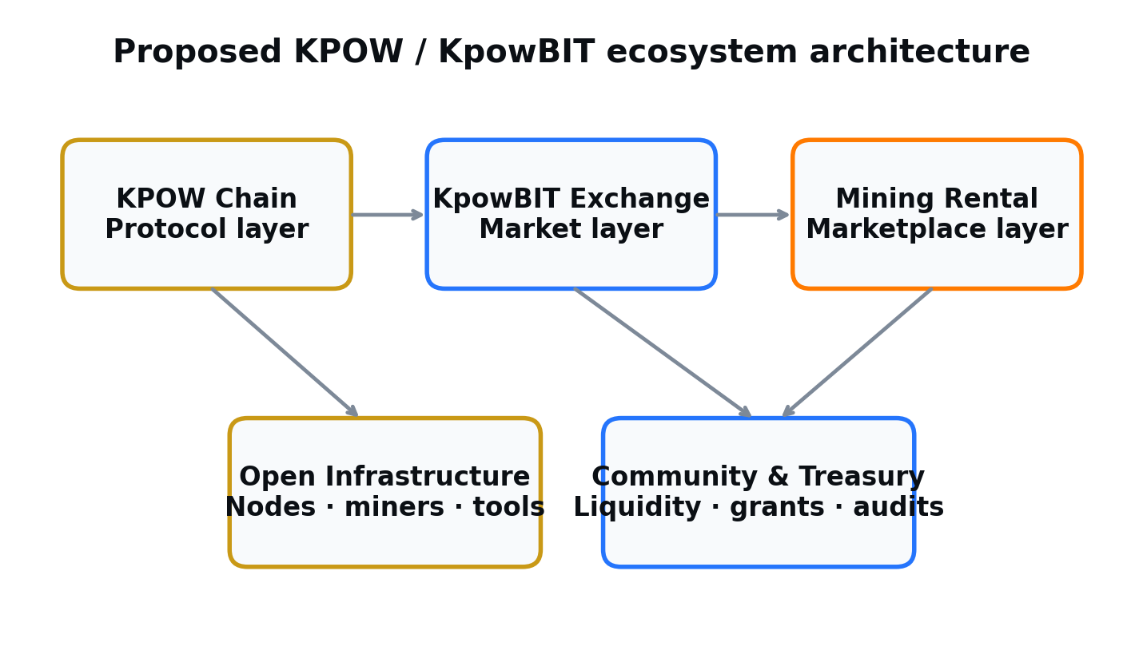
Figure 1. Proposed separation between KPOW Chain, KpowBIT products, and open infrastructure.

4.1 KPOW Chain
The proposed native settlement network provides Proof-of-Work consensus, KPOW issuance, EVM execution, gas accounting, asset settlement, and smart-contract infrastructure.

4.2 KpowBIT Exchange
The first planned production product provides user accounts, wallets, deposits, withdrawals, spot markets, operational monitoring, and APIs. It also creates a market access point for KPOW and supported Proof-of-Work assets.

4.3 Mining Rental Platform
A planned two-sided marketplace targeted for approximately Q2 2027. Renters compare verified offers and contract terms. Providers publish eligible GPU or ASIC capacity, receive orders, deliver hashrate, and settle completed contracts under marketplace rules.

4.4 Open infrastructure
Explorers, nodes, mining clients, pools, RPC endpoints, monitoring, developer tools, and future third-party integrations expand the network beyond products operated directly by KpowBIT.

5. KPOW Chain Architecture
Proposed technical structure

5.1 Node responsibilities
- Validate blocks, transactions, signatures, gas, and state transitions.
- Maintain the canonical chain according to Proof-of-Work fork-choice rules.
- Expose JSON-RPC, WebSocket, and optional IPC interfaces for wallets, explorers, and applications.
- Execute EVM-compatible smart contracts deterministically.
- Enforce maximum-supply, block-reward, and terminal reward-block rules from genesis.

5.2 Proof-of-Work consensus
Proof of Work creates an objective cost for extending and reorganizing chain history. KPOW currently specifies Ethash as the proposed mining algorithm. Miners compete to produce valid blocks; nodes independently verify the work and resulting state transition. Ethash parameters, DAG behavior, miner compatibility, difficulty response, and pool integration remain subject to benchmark, security review, and public testnet results.

5.3 EVM execution
The planned client profile is based on the Octa/Core-Geth family of EVM-compatible source code, with project-specific network identity, genesis configuration, consensus parameters, ports, chain IDs, monetary rules, and release tooling. EVM compatibility is intended to support Solidity contracts and widely used Ethereum development tools. The inherited codebase must be audited, reproducibly built, renamed completely, and validated independently before any production release.

5.4 Difficulty adjustment
A new network may experience rapid changes in hashrate. A long fixed retarget window can make blocks extremely slow after miners leave or excessively fast after miners arrive. KPOW therefore proposes per-block difficulty adjustment, with ASERT or a similarly tested method as the leading design direction, subject to simulation and testnet validation.

5.5 Network interfaces
Interface | Purpose
P2P | Block and transaction propagation between nodes
JSON-RPC | Wallet, explorer, exchange, and application integration
WebSocket | Event subscriptions and real-time application updates
CLI | Node operations, mining configuration, wallet and developer workflows
Explorer API | Public chain data, transaction inspection, and verification

6. Network Parameters
Current proposed mainnet and testnet configuration
Parameter | Proposed value | Status / note
Coin / network name | KpowBIT / KPOW Network | Proposed
Native symbol | KPOW | Proposed
Consensus | Proof of Work | Core design
Mining algorithm | Ethash | Proposed; public testnet validation required
Client reference | Octa / Core-Geth family | Fork, rename, audit, and reproducible-build work required
Execution | EVM compatible | Subject to compatibility testing
Maximum supply | 21,000,000 KPOW | Fixed monetary cap
Mining allocation | 14,700,000 KPOW (70%) | Created through valid block rewards
Ecosystem & Liquidity | 4,200,000 KPOW (20%) | Genesis allocation with published controls
Development Fund | 2,100,000 KPOW (10%) | Genesis allocation with published controls
Block reward | 4 KPOW | Constant until terminal reward block
Target block time | 30 seconds | Target; actual intervals vary
Reward end block | 3,675,000 | Block subsidy becomes zero afterward
Target mining period | Approximately 3.5 years | At 30-second average blocks
Difficulty adjustment | Per block | ASERT or tested equivalent proposed
Address format | 0x... | EVM-compatible accounts
Mainnet Chain ID | 112026 (0x1B59A) | Proposed
Testnet Chain ID | 122026 (0x1DCAA) | Proposed
P2P port | 39000 | Node-to-node traffic
JSON-RPC port | 8545 | HTTP RPC
WebSocket port | 8546 | Event subscriptions

Parameter governance
Consensus-critical values must be finalized before genesis, encoded in the client, documented in the mainnet specification, and validated on public testnet. Changes after launch require transparent upgrade procedures.

6.1 Planned RPC and wallet configuration
KPOW uses EVM-compatible account addresses and is intended to be added as a custom network in compatible browser and mobile wallets. The public URLs below are planned project endpoints and must not be treated as live until officially announced, monitored, and independently verified.
Wallet field | KPOW Mainnet | KPOW Testnet
Network name | KPOW Mainnet | KPOW Testnet
RPC URL | https://rpc.kpowbit.com | https://testnet-rpc.kpowbit.com
WebSocket URL | wss://ws.kpowbit.com | wss://testnet-ws.kpowbit.com
Chain ID | 112026 / 0x1B59A | 122026 / 0x1DCAA
Currency symbol | KPOW | KPOW test token
Explorer | https://scan.kpowbit.com | https://testnet-scan.kpowbit.com
Current status | Planned - not live until announced | Planned - not live until announced
Proposed project allocation address: 0xad87d5514e5f40c83240c390b06339b834cb7e67. This address must not be used for deposits or purchases unless its purpose, authorized signers, chain, and official status are published through verified project channels.

7. Monetary Policy and Mining Schedule
A constant 4 KPOW subsidy until block 3,675,000
The protocol mining allocation is 14,700,000 KPOW, equal to 70% of the 21,000,000 maximum supply. Each valid block produces 4 KPOW until block 3,675,000. After the terminal reward block, the block subsidy becomes zero and miners must rely on transaction fees or other protocol-approved compensation that does not exceed the maximum supply.
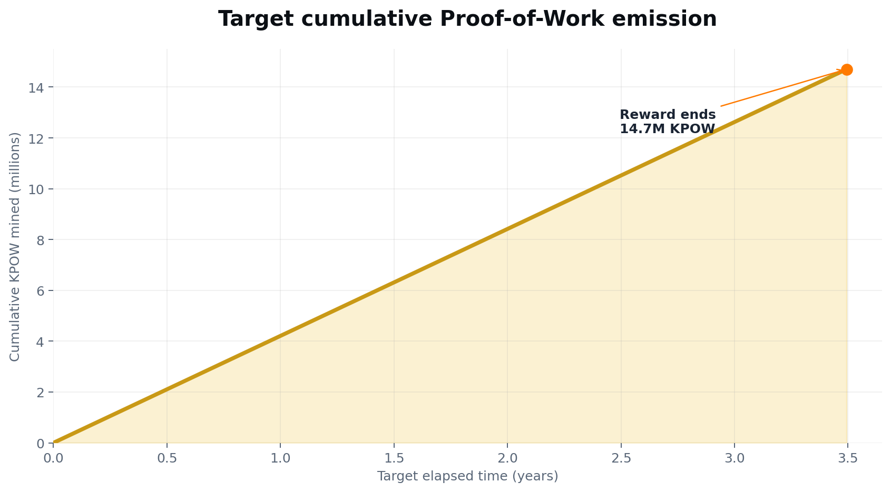
Figure 2. Target cumulative mining emission at 4 KPOW per block and a 30-second target block time.
Metric | Calculation | Result
Mining allocation | 4 KPOW × 3,675,000 blocks | 14,700,000 KPOW
Target blocks per day | 86,400 seconds ÷ 30 seconds | 2,880 blocks
Target daily emission | 2,880 × 4 KPOW | 11,520 KPOW
Target mining duration | 3,675,000 × 30 seconds | 110,250,000 seconds
Approximate duration | 110,250,000 ÷ 31,557,600 | 3.49 years

7.1 Mining Economics After Subsidy
No halving schedule and a defined terminal reward block
The current design uses a constant block reward rather than periodic halvings. This simplifies supply accounting and makes the terminal mining date easier to estimate. It also concentrates subsidy issuance into a relatively short period, so network security, miner economics, circulating supply, exchange liquidity, and fee sustainability must be studied carefully during testnet.

7.2 Transaction fees after subsidy
Base-layer transaction fees are expected to compensate miners as the subsidy approaches zero. Fee-market behavior, minimum relay policy, block gas limits, transaction demand, and post-subsidy security require simulation and stress testing before mainnet.
The project should monitor the percentage of miner revenue produced by subsidy versus fees throughout testnet and mainnet. If fee demand is insufficient, security may decline when the block subsidy ends. Any response must preserve the 21 million maximum supply and be disclosed through transparent protocol governance.

7.3 Supply accounting
Maximum supply, mined supply, genesis allocation, circulating supply, locked supply, treasury balances, and vesting balances should be reported separately. Unmined protocol rewards must not be represented as circulating supply.
Post-subsidy test requirement
Before mainnet, stress tests should model low fees, changing hashrate, block-space demand, pool concentration, and miner exit around block 3,675,000.

8. Tokenomics and Distribution
A 70/20/10 allocation centered on Proof of Work
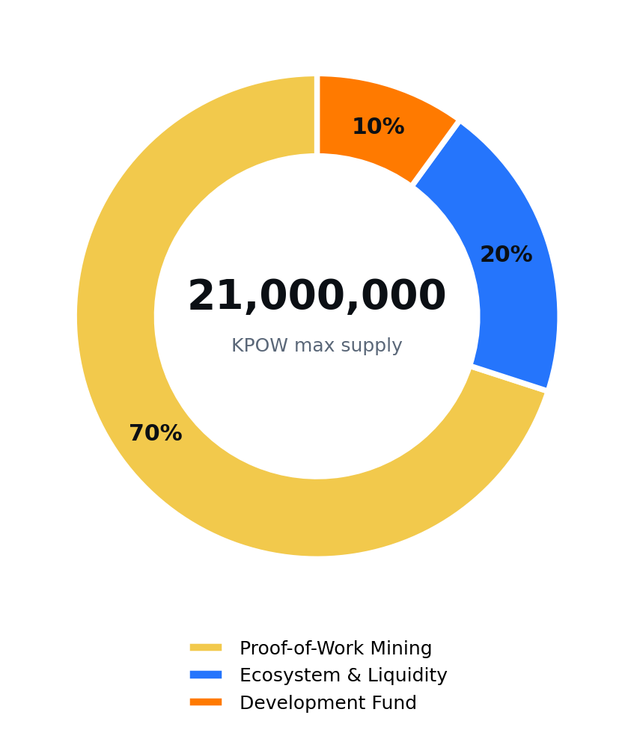
Figure 3. Proposed KPOW maximum-supply allocation.

8.1 Allocation Details
Purpose, controls, and circulating-supply treatment
Allocation | Share | KPOW amount | Primary purpose
Proof-of-Work Mining | 70% | 14,700,000 | Block rewards through block 3,675,000
Ecosystem & Liquidity | 20% | 4,200,000 | Presale, liquidity, community programs, listings, incentives, grants, ecosystem growth
Development Fund | 10% | 2,100,000 | Engineering, audits, infrastructure, operations, legal/compliance, integrations, long-term development

8.2 Proof-of-Work Mining - 70%
This allocation enters circulation only through valid blocks. It is not held in an insider wallet before mining. The terminal block and maximum mining emission are deterministic under the proposed consensus rules.

8.3 Ecosystem & Liquidity - 20%
This allocation may support the presale, exchange liquidity, community airdrops, user incentives, market integration, ecosystem grants, and future marketplace bootstrap programs. Exact sub-allocations, lockups, and release schedules must be published before the corresponding program begins.

8.4 Development Fund - 10%
The development fund supports node and wallet engineering, explorer and RPC infrastructure, security audits, exchange and marketplace development, legal and compliance work, operations, integrations, documentation, and long-term maintenance. The fund should be held under multi-signature control with public addresses and periodic reporting.

8.5 Circulating supply
Initial circulating supply is not defined by the maximum supply alone. It depends on presale release, liquidity provisioning, airdrop distribution, development-fund lockups, and mined blocks. A circulating-supply policy and wallet disclosure should be published before market launch.

9. Presale Framework
Planned before KPOW Network and KpowBIT Exchange release
The KPOW presale is planned before the public release of KpowBIT Exchange. Presale KPOW must come from the Ecosystem & Liquidity allocation; it does not increase the 21 million maximum supply.
Presale design area | Proposed approach
Payment asset | USDT only
Supported payment networks | Ethereum, BNB Smart Chain, and Polygon, subject to final configuration
Allocation record | KPOW receiving address and verified payment transaction
Price | To be published in official presale terms
Minimum / maximum | To be published and enforced per wallet / participant
Hard cap | Limited by the published presale sub-allocation
Vesting / delivery | To be disclosed before purchase and implemented through auditable records or contracts
Eligibility | May require KYC, sanctions screening, jurisdiction restrictions, and acceptance of terms

- Presale proceeds should be received by disclosed treasury or multi-signature addresses.
- Payment token contracts and treasury addresses must be published for each supported network.
- Transaction verification should confirm chain ID, USDT contract, payer, recipient, amount, receipt status, and confirmations.
- Presale dashboards must distinguish committed, paid, verified, distributed, locked, refunded, and rejected allocations.
- No presale page should promise guaranteed listing price, liquidity, return, mining profit, or token appreciation.
Presale disclosure requirement
Final price, allocation, schedule, wallet addresses, vesting, refund policy, restricted jurisdictions, and delivery mechanism must be released in a separate official Presale Terms document before payments are enabled.

10. KpowBIT Exchange
The market layer planned after KPOW Network launch
KpowBIT Exchange is planned after the KPOW Network testnet and mainnet milestones. This sequencing allows the exchange to integrate the native KPOW chain, confirmations, deposits, withdrawals, explorer links, and network monitoring as part of its initial KPOW market support.
Product area | Planned capability
Accounts | Registration, authentication, account security, eligibility controls, and support workflows
Wallet infrastructure | Deposits, confirmations, balances, withdrawals, monitoring, hot/cold wallet controls
Spot markets | Order placement, matching, order books, trades, fees, and market information
PoW asset support | Integration processes for nodes, wallets, confirmations, maintenance, and risk monitoring
APIs | Public market data, authenticated trading, account, wallet, and operational integrations
Security | 2FA, withdrawal controls, monitoring, incident response, key management, and audits

10.1 Network-first exchange sequencing
Launching KPOW Network before KpowBIT Exchange reduces integration ambiguity for native deposits and withdrawals. The exchange can still provide the operational account, wallet, market, support, and monitoring foundation required by the later rental marketplace.

10.2 KPOW market access
KpowBIT Exchange may provide a market for KPOW after chain, wallet, custody, legal, liquidity, and operational requirements are satisfied. Listing timing, pairs, market-making arrangements, and withdrawal availability must be announced separately.

10.3 Proof-of-Work market focus
The exchange is intended to support established and emerging Proof-of-Work communities with transparent wallet status, chain monitoring, maintenance communication, and market operations.

11. Mining Rental Platform
Planned two-sided marketplace targeted for Q2 2027
The Mining Rental Platform is planned as a marketplace connecting renters who need mining capacity with providers operating eligible GPU or ASIC infrastructure. The target is approximately Q2 2027, subject to engineering, provider readiness, security review, and regulatory assessment.
Renter workflow | Provider workflow
Create and fund an eligible account | Apply and complete provider verification
Select coin, algorithm, pool, or mining package | Connect and register eligible hardware
Compare hardware, hashrate, price, duration, uptime, and rating | Benchmark hardware and verify identity / stability
Accept terms and start a rental | Publish capacity, price, duration, and maintenance windows
Monitor hashrate, shares, uptime, and contract time | Deliver measurable service under platform telemetry
Complete, extend, or dispute under published rules | Receive eligible settlement after verification and dispute window

11.1 Marketplace listing data
- Hardware model and quantity
- Supported algorithm and software profile
- Advertised and observed hashrate
- Price, billing unit, minimum duration, and fees
- Region, connectivity, latency, and availability
- Provider uptime, completed contracts, cancellations, disputes, and rating
- Collateral, refund, failure, maintenance, and dispute terms

11.2 Delivery verification
Provider payment should depend on measured delivery. Verification may combine platform telemetry, pool-side data, accepted shares, session logs, hardware identity, uptime, and contract records. Self-rental, circular payment, false benchmarks, hardware substitution, and manipulated uptime should be monitored and penalized under published rules.

11.3 Profitability disclosure
Mining output and financial performance depend on asset price, network difficulty, pool conditions, fees, electricity economics, hardware efficiency, downtime, and market conditions. Estimates are not guarantees, and the platform should not advertise fixed or risk-free returns.

12. KPOW Utility
Native functions across protocol and product layers
Layer | Potential KPOW utility
KPOW Chain | Gas fees, smart-contract deployment, asset settlement, and miner compensation
Mining | Block rewards and transaction-fee revenue
KpowBIT Exchange | Potential trading-fee discounts, campaign rewards, VIP access, or supported market functions
Mining Rental | Potential service discounts, provider collateral, settlement, reputation bonds, or ecosystem incentives
Community | Airdrops, grants, contributor programs, and future governance participation
Infrastructure | Developer grants, node or pool programs, audits, integrations, and open tooling

Utility must be activated only when the corresponding product and control framework are ready. Token utility should not be described as guaranteed profit, interest, passive income, or a right to company revenue unless a legally reviewed structure explicitly provides such rights.
Protocol and product separation
KPOW Chain can remain a neutral settlement protocol while KpowBIT products apply account rules, fees, eligibility, collateral, support, and dispute procedures at the application layer.

13. Security and Risk Controls
Defense in depth across chain, exchange, presale, and rental services
Area | Primary controls
Consensus | Public testnet, deterministic validation, difficulty simulation, reorganization testing, client review
Wallets and treasury | Multi-signature control, cold storage, limited hot-wallet exposure, transaction monitoring, backup and recovery
Presale | Signed quotes, chain-specific verification, duplicate transaction prevention, allocation caps, disclosed treasury addresses
Exchange | 2FA, withdrawal controls, key management, monitoring, rate limits, incident response, audit logs
Rental marketplace | Hardware verification, telemetry, collateral, reputation, dispute rules, anti-self-rental and anti-wash controls
Software supply chain | Reproducible builds, dependency review, signed releases, vulnerability disclosure, patch process

- Public testnet should run long enough to expose unstable difficulty, network partitions, mining oscillation, wallet failures, and EVM compatibility issues.
- Consensus code, vesting contracts, presale verification, treasury processes, exchange custody, and rental settlement require independent review appropriate to their risk.
- Critical keys and production secrets must never be embedded in frontend code, public repositories, or client-delivered environment variables.
- Incident response should define severity, containment, user communication, withdrawal controls, evidence retention, and recovery procedures.

14. Governance and Treasury Transparency
Controls before decentralization claims
Early project governance is expected to be operational rather than fully decentralized. The project should clearly identify who controls consensus releases, genesis wallets, exchange operations, treasury spending, presale configuration, and marketplace policy.
Transparency item | Recommended disclosure
Genesis allocation | Wallet addresses, purpose, amount, lock, vesting, and authorized signers
Ecosystem & Liquidity | Presale sub-allocation, liquidity inventory, airdrop budgets, grants, and remaining balance
Development Fund | Multi-signature address, budget categories, spending approvals, vesting or release schedule
Circulating supply | Methodology, excluded locked wallets, mined supply, released genesis balances, and reporting frequency
Software governance | Repository, licenses, release signing, upgrade policy, supported versions, and security contacts
Future governance | Scope of community voting, eligibility, quorum, timelocks, emergency powers, and legal limitations

Community governance should not be introduced as a marketing label before voting scope, treasury authority, emergency powers, quorum, execution, and accountability are defined. Security-sensitive actions may require time delays, multi-signature execution, or staged activation.

15. Era Plan
Presale, network, exchange, rental, and open-utility milestones
Era | Target period | Primary milestones
Era I - Presale & Community | Q3 2026 | Publish the whitepaper and final presale terms; configure USDT payments on supported networks; disclose allocation and treasury controls; complete community onboarding and airdrop verification.
Era II - KPOW Network | Q4 2026 | Publish the final technical specification; release public testnet, node, RPC, explorer, mining client, and pool integration; validate Ethash, difficulty, 30-second blocks, reward rules, and genesis allocation; launch mainnet when readiness criteria are met.
Era III - KpowBIT Exchange | Q1 2027 | Launch and stabilize KpowBIT Exchange after KPOW Network; integrate the KPOW mainnet wallet, deposits, withdrawals, confirmations, explorer links, spot markets, account controls, and operational monitoring.
Era IV - Mining Rental | Q2 2027 | Onboard and verify selected GPU and ASIC providers; implement searchable offers, contract monitoring, metering, settlement, dispute controls, and closed beta before targeted public release.
Era V - Open Utility | Q3 2027-2028+ | Expand nodes, pools, wallets, developer tools, APIs, provider regions, KPOW utility, grants, open integrations, and transparent governance modules.

Roadmap rule
Dates are targets, not guarantees. A milestone should move forward only when engineering, security, liquidity, operational, provider, and legal readiness are sufficient.

16. Risk Factors
Material risks that participants should evaluate

Technology risk
Consensus, EVM, wallet, explorer, API, exchange, and marketplace software may contain defects, vulnerabilities, or incompatibilities.

Network-security risk
A new Proof-of-Work network may have low or volatile hashrate, making reorganizations, mining attacks, oscillation, or stalled blocks more likely.

Post-subsidy security risk
The proposed subsidy ends after approximately 3.5 target years. Transaction-fee revenue may be insufficient to maintain desired security unless network usage and miner economics develop.

Liquidity and market risk
KPOW may experience low liquidity, high volatility, market manipulation, price gaps, or no sustainable market.

Presale risk
Technical, legal, operational, or market events may delay exchange release, token delivery, liquidity, or project milestones.

Custody and counterparty risk
Exchange, treasury, payment, market-making, infrastructure, or provider counterparties may fail or be compromised.

Mining and rental risk
Hardware may underperform, fail, become incompatible, or produce lower output due to difficulty, pool conditions, fees, downtime, or price changes.

Regulatory risk
Token sales, exchanges, mining services, custody, promotions, and cross-border payments may be restricted or require licensing, KYC, reporting, or product changes.

Roadmap risk
The exchange, chain, rental marketplace, integrations, and governance plans may be delayed, changed, reduced, or discontinued.

17. Legal and Regulatory Considerations
Availability depends on jurisdiction and final structure
This whitepaper does not create a contract, fiduciary duty, partnership, guaranteed service, ownership right, debt claim, revenue share, or promise of return. Final rights and obligations arise only from applicable terms, contracts, laws, and on-chain records.
- Presale participation may be unavailable to residents of restricted jurisdictions or sanctioned persons.
- Identity verification, source-of-funds review, transaction monitoring, tax reporting, or other controls may apply.
- Exchange and custody services may require licensing, registration, local partners, or jurisdiction-specific restrictions.
- Mining rental services may be limited by consumer-protection, financial, cloud-service, energy, tax, or digital-asset rules.
- Marketing materials must avoid guaranteed-return claims and clearly distinguish forecasts, targets, estimates, and live data.
- Final presale terms, exchange terms, risk disclosures, privacy policy, and marketplace terms should be reviewed by qualified counsel.
No reliance
Users should not rely on this draft as the sole basis for purchasing KPOW, trading, mining, providing hardware, or entering a rental contract.

Appendix A. Monetary Calculations
Reproducible supply and duration formulas
Calculation | Formula | Result
Proof-of-Work allocation | 21,000,000 × 70% | 14,700,000 KPOW
Ecosystem & Liquidity | 21,000,000 × 20% | 4,200,000 KPOW
Development Fund | 21,000,000 × 10% | 2,100,000 KPOW
Terminal reward block | 14,700,000 ÷ 4 | 3,675,000 blocks
Target blocks per hour | 3,600 ÷ 30 | 120 blocks
Target blocks per day | 86,400 ÷ 30 | 2,880 blocks
Target daily emission | 2,880 × 4 | 11,520 KPOW
Target elapsed seconds | 3,675,000 × 30 | 110,250,000 seconds
Target elapsed days | 110,250,000 ÷ 86,400 | 1,276.04 days
Target elapsed years | 1,276.04 ÷ 365.25 | 3.49 years

Actual calendar duration may differ because the block interval is a target average. Temporary hashrate changes, difficulty adjustment, network conditions, timestamp rules, and implementation behavior can make blocks faster or slower than 30 seconds.

Appendix B. Terminology
Definitions used in this document
Term | Meaning
Maximum supply | The highest total number of KPOW that consensus permits to exist.
Mining allocation | KPOW created only through valid block rewards.
Genesis allocation | KPOW assigned at network genesis to disclosed ecosystem and development wallets.
Circulating supply | KPOW reasonably available to the public market, excluding locked, unmined, and restricted balances under the published methodology.
Block reward | New KPOW created for a valid block before the terminal reward block.
Terminal reward block | The final block eligible for the 4 KPOW subsidy under the proposed design.
EVM compatibility | Ability to execute Ethereum Virtual Machine bytecode and use compatible development tools, subject to implementation details.
Provider | An approved operator listing eligible GPU or ASIC mining capacity.
Renter | A user purchasing temporary access to listed mining capacity.
Transparent hybrid launch | A launch with both protocol-mined supply and disclosed genesis allocation; not a pure fair launch.

Appendix C. Pre-Mainnet Checklist
Minimum publication and validation items
☐ Final consensus specification and mining algorithm published.
☐ Genesis block, allocation file, wallet addresses, locks, and vesting published.
☐ Maximum supply, terminal reward block, and overflow / boundary tests independently verified.
☐ 30-second block target and per-block difficulty behavior tested under hashrate shocks.
☐ Node, miner, wallet, explorer, RPC, and EVM compatibility tested on public testnet.
☐ Reorganization, timestamp, peer, transaction-pool, gas, state, and denial-of-service tests completed.
☐ Reproducible builds, signed binaries, licenses, source attribution, and vulnerability process published.
☐ Presale terms, payment contracts, treasury addresses, allocation records, vesting, and restricted jurisdictions published.
☐ Exchange wallet, listing, custody, withdrawal, incident, support, and maintenance procedures reviewed.
☐ Rental provider onboarding, metering, settlement, collateral, refund, dispute, and anti-fraud policies tested before beta.
☐ Circulating-supply methodology and reporting process published.
☐ Independent security and legal reviews completed at a level appropriate to launch risk.

☐ Mainnet and testnet RPC, WebSocket, explorer, Chain ID, and wallet configuration published and tested.
☐ Public endpoints monitored for synchronization, rate limits, archive requirements, and security exposure.
☐ Project allocation wallets, signers, purpose, lock conditions, and genesis balances independently verifiable.
☐ Octa/Core-Geth fork history, licenses, renamed identifiers, signed releases, and reproducible build instructions published.
End of Draft v0.3
This document will be revised as testnet results, presale terms, technical reviews, security audits, public endpoints, and product milestones become available. Official updates should be obtained only from KpowBIT-controlled channels.

